REPORT OF HANGMAN GAME DEVELOPMENT IN 16 bit ASSEMBLY LANGUAGE(NASM)

DATE: 19 JANUARY 2021 REPORTED BY : MUQADDAS FATIMA
P18-0076
JAVAIRIA REHMAN
P19-0020
INTRODUCTION
This report provides an algorithm for the realization of popular computer game Hangman. The basic idea of this work was the development of Hangman in 16 bit assembly programming language, using NASM and dosbox.
Assembly language is a low-level programming language, and it is specific to a particular processor (micro controller) architecture. As the oldest programming language, and of all languages, it bears the closest resemblance to a native machine language. It provides a direct access to computer hardware, requiring you to understand much about your computer’s architecture and operating system.
A large number of modern micro-controllers are based on a similar architecture as the micro-controller 8088 and have similar abbreviations for the names of assembly instructions. So, the study of micro-controller 8088 is reckoned not only for pedagogical reasons but also for usability.
Note :Report is organized as follows. Section II provides the game specification. In section III are described functions and concepts used for developing the game. Concluding remarks are given in section IV.

II. GAME SPECIFICATION

The game is realized using the already known term which is to be guessed.
In this game we have used first screen just for intro with some text printed about the hangman game. Game starts when we go to second screen. At the beginning of the game, the player tries to guess the term by writing letters from the standard input, and hangman is already there in the game. If the entered letter does not exist in the specified term , it shows the message wrong guess and part of the hangman disappears so on till all the turns are completed. If all the guesses are wrong then it print a message that you lose. However, if the letter exists in the term which a player tries to guess, then the letter is written to the appropriate position in the word. If the letter has already been hit, the user is informed necessarily about it, and if the user by accident writes it, then it does not affect the game. Every time a new letter is entered from the standard input, it is necessary to print it on the screen. When a user guesses the current term, they are allowed to hit the new one. If the user misses the letters enough times, the entire Hangman is disappears, and a player loses the game. Here are the steps used in the game:

FIRST PAGE:
PRINTS NAME OF MEMBERS AND GAME LOGO
2ND PAGE:
GAME STARTS , GENERATES RENDOMNUMBER

SELECT STRING BASED ON THAT NUMBERS

CREATES DASHES AND PRINTS STRINGS

GAME
GENERATES OUT PUT ACCORDING TO THE
SITUATION. PRINT GAME WIN OR YOU LOSE.

Fig : A simplified program diagram

The description of the project code and the principle of the game operation are described through the program flow diagram depicted in Fig .1.In diagram from Fig. 1, each of the segments will be explained in separate subsections.

Section 1:first screen of program.
This first screen is in orange color and displays game name and some other string including members name. For this we used a clrscr program and then we used a function for orange background codes are in fig .2 :
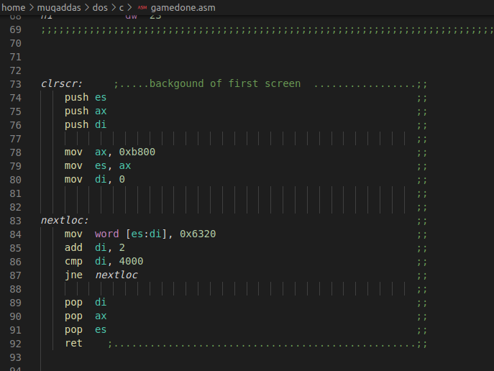

fig 2: code of first screen of program

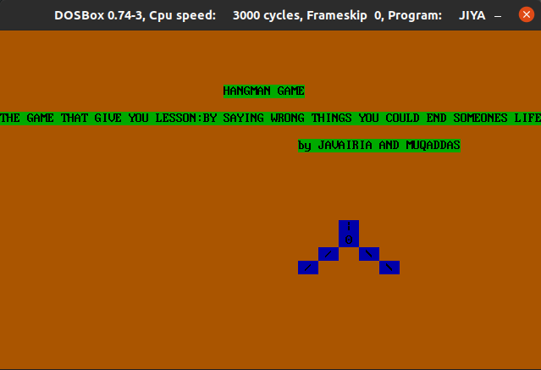

fig .a: output of first screen

section 2: 2nd screen of program

This 2nd screen is in blue color and actual game starts from here ,on this screen all other steps are done and game also terminates here. For this we used a clrscr program and then we used a function for blue background codes are in fig .3:

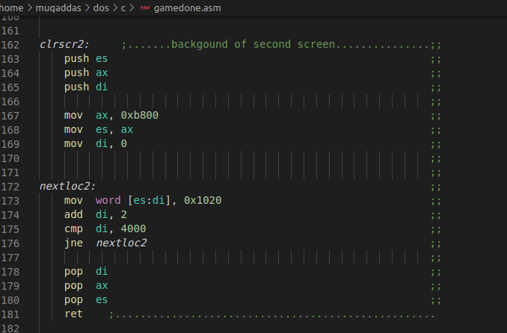

fig .3 : 2nd screen of game

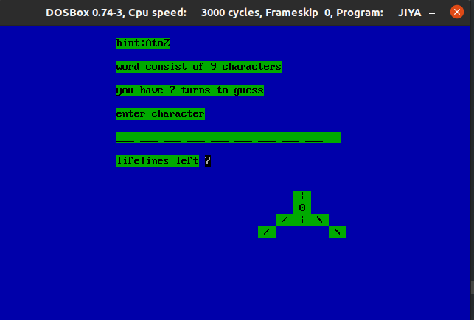

fig : output of 2nd screen

section 3: Random number function.

Generating a random number we have achieved the power of two functions. The Randomize function restarts the randomly generated number based on the current time. If we did not use this function, we would always have the same random number. The Random Range function generates an unsigned pseudo-random 16-bit integer in the range 0 to N-1. In our case, it generates a number from 0 to 2. The code that realizes this is shown in FIG .4:

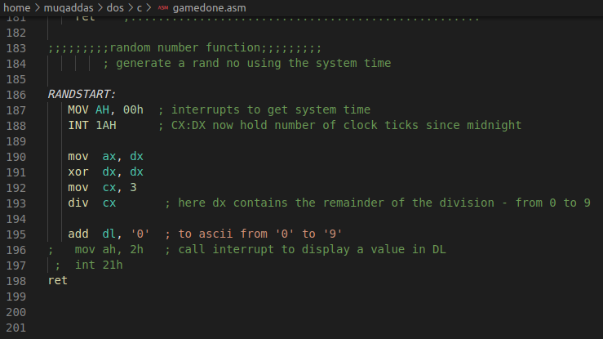

SECTION 4: WORD CHOOSING AND GENERATING HINTS
we have created hints also for the player to guess easily. And based on the randomly generated number, we need to select one of the ten words, which we have previously defined. Fig. 5 shows the declaration of the string of all the words that can be selected.
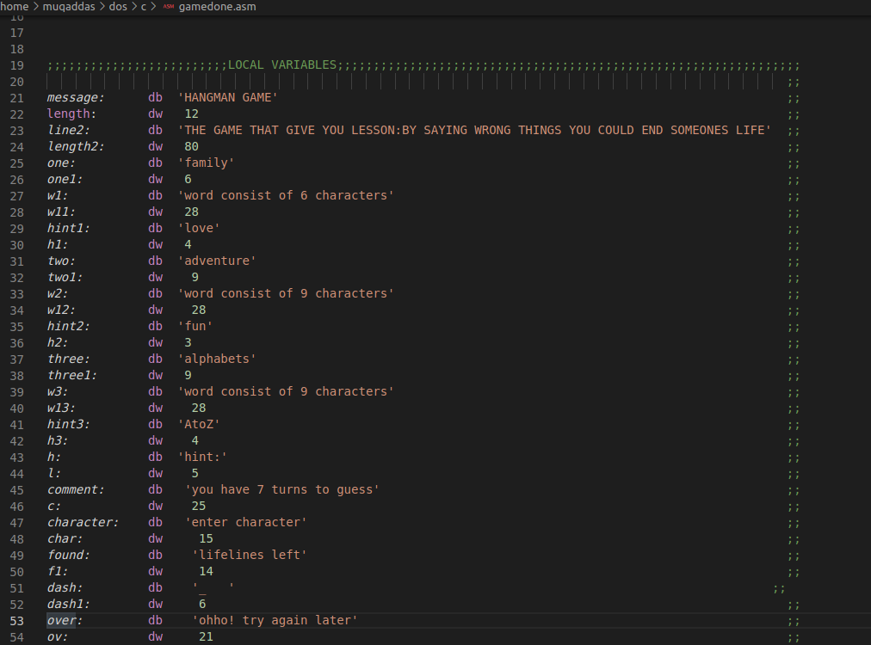

SECTION 5: CREATING STRING OF DASHES AND PRINT STRING PROGRAM
After we have chosen the word we are guessing, we need to form a series of dashes that will be of the same length as the chosen word. On the screen, we will print all the dashes in the first interaction, and later as the player will enter the letters, replace the corresponding dashes with the letters in the appropriate places as well as in the selected word.

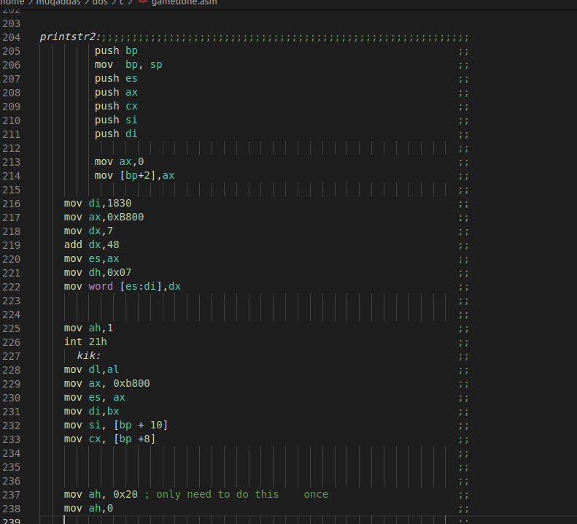

SECTION 6: SEVEN LIFELINES(LIMIT FOR GUESSES)
There is a limit of 7 for the player to guess the character and if all the limit exceeds and all guesses are wrong then players loses the game.
Output of game:
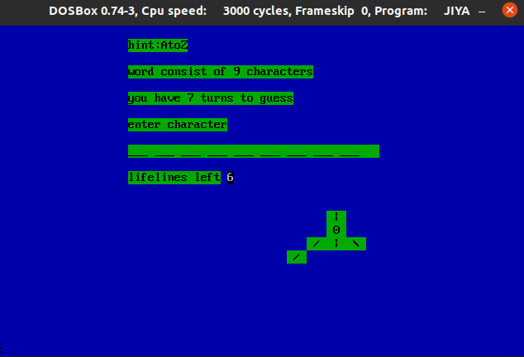
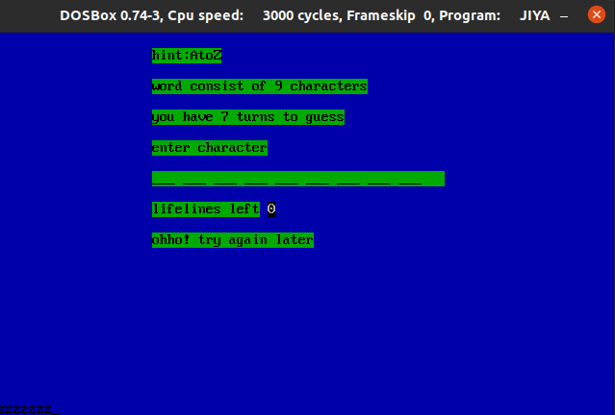

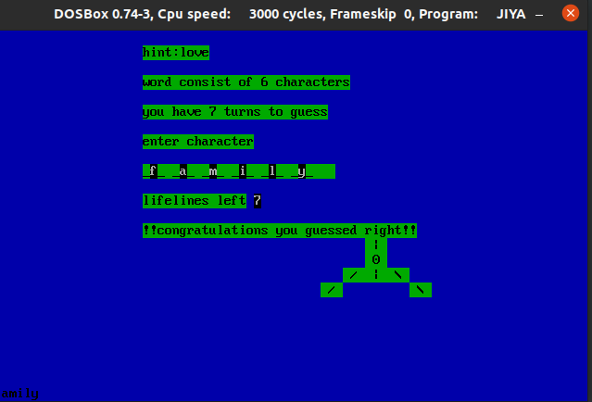

GAME FLOW DIAGRAM

FIRST SCREENT
PRESS
ENTER

SECOND SCREEN
INPUT
CHAR
IF WRONG
GUESS

WRITE IT
PRINT
ON SCREEN

ALREADY EXISTS
IGNOR

NEXT
CHAR

GUESS
END
LIFE LINE DEC

IF LIFE =0
ALL
GUESSES
RIGHT

GAME LOSE

GAME WIN

GAME OVER

Here all code of the game is done.

Conclusion :

In this report, we describe a realization of the game Hangman. Although the game is well known and built numerous times, our realization gives an exciting approach to a programming assignment made entirely in assembly programming language. This realization in this game provides an exciting way to introduce the game in assembly programming and architecture of x88 processors..

